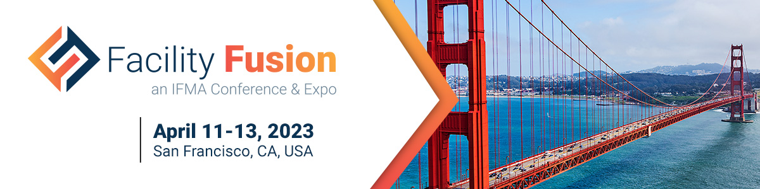

Promote your participation and encourage your customers to join you at IFMA’s Facility Fusion this year. Follow these 3 simple steps below to share on your social media channels (LinkedIn, Facebook, Instagram and Twitter):

- Download the exhibitor social cards and chose the image version that best fits the social media channel you are posting on: Social Cards_Exhibitor Add the photo to your post.
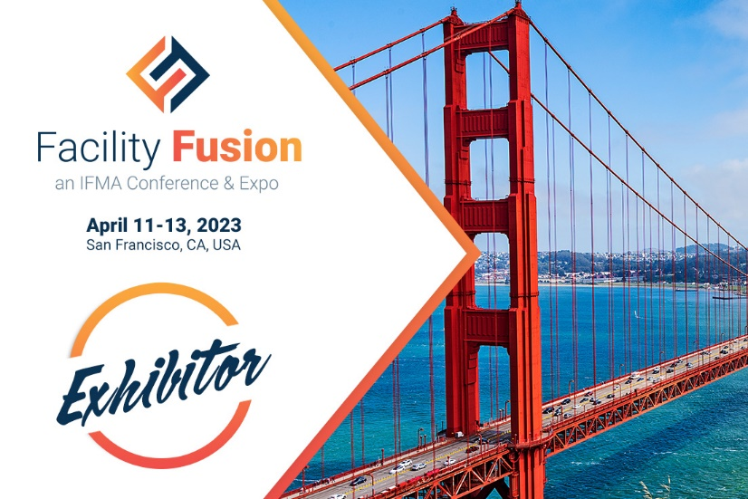
- Use sample template(s) below for your post (feel free to customize):

Template #1
Facility Fusion is all about focus — on your needs as a facility manager, on your concerns in supporting specific facility types, on your career advancement and on building your professional network. What you learn and who you meet benefit both you and your employer.

Join <Exhibiting Company Name> at IFMA’s Facility Fusion® Conference and Expo in San Francisco, California. The Facility Fusion expo connects you to those in the business of solving your biggest facility issues. You won’t want to miss!

Not registered yet? Don’t wait! https://facilityfusion.ifma.org/

#facilityfusion #facilitymanagement #FM #conference #expo #builtenvironment

OR

Template #2
<Exhibiting Company Name> is looking forward to exhibiting at IFMA’s Facility Fusion® Conference and Expo on April 11-12 in San Francisco, California! At Facility Fusion, you will discover top FM solutions and have hands-on access to new and necessary products and services. Visit our booth to learn about <include top 3 reasons for customers to visit your booth>

Register to attend at https://facilityfusion.ifma.org/

#facilityfusion #facilitymanagement #FM #conference #expo #builtenvironment
- Tag IFMA so we can share your post as well! Then click on ‘Post’.
#facilityfusion
LinkedIn & Twitter: @IFMA
Facebook: @InternationalFacilityManagementAssociation
Instagram: @ifma_hq

